**Lab 3**

**A. Data Import**

a. Download northwind-db.sql from classroom link

b. Open MySQL Workbench and Login using root or <name>

c. Create database <name> northwind

**Query:**create a database rajannorthwind;

**Output:**

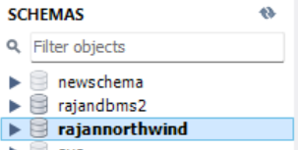

1. Import downloaded database in <name> northwind

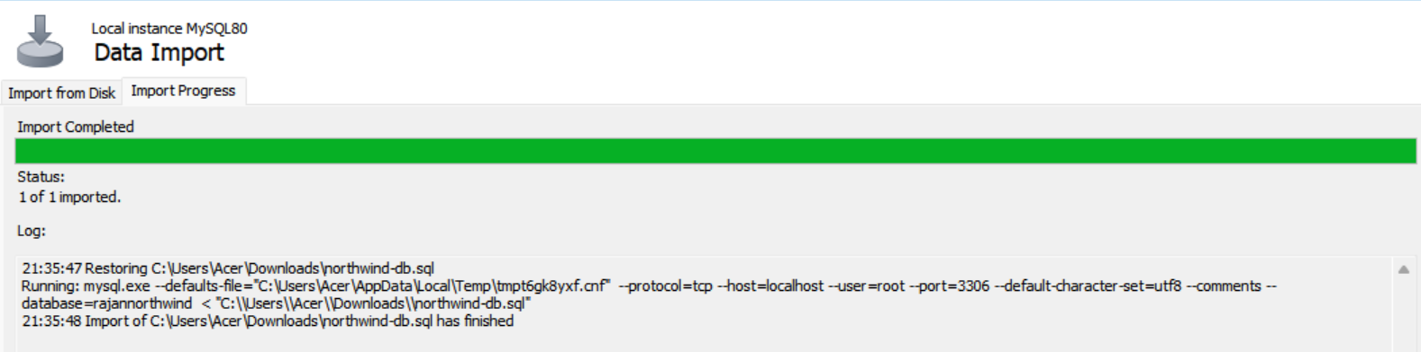

e. Check Total Row Count in each table

**Query:**

select count(*) from categories;

select count(*) from customers;

select count(*) from employees;

select count(*) from orderdetails;

select count(*) from orders;

select count(*) from products;

select count(*) from shippers;

select count(*) from suppliers;

**Output:**

Categories

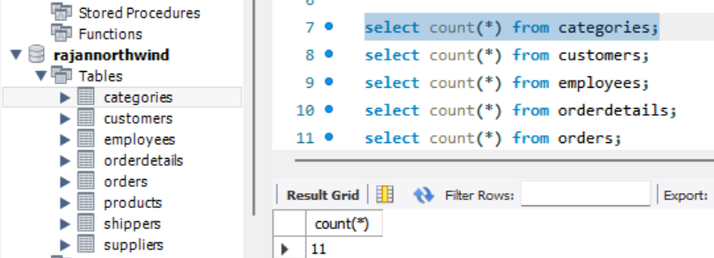

Customers

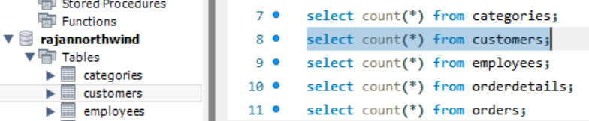

Employees

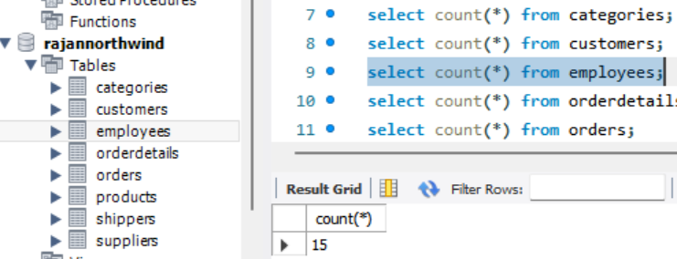

Order Details

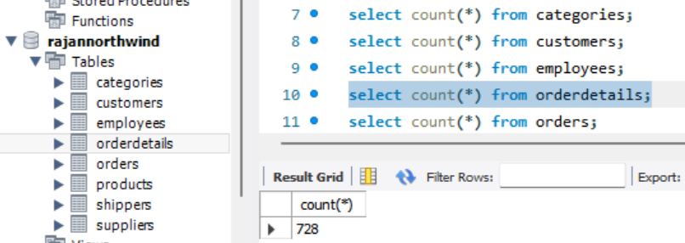

Orders

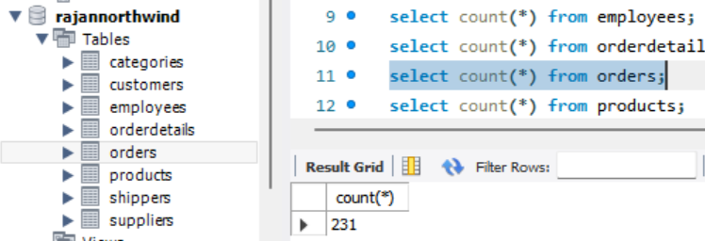

Products

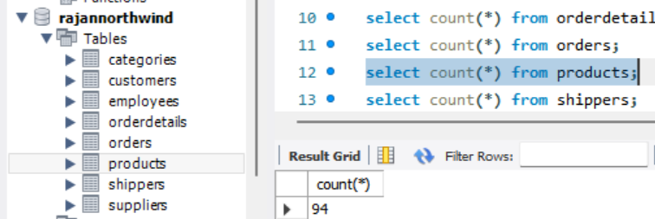

Shippers

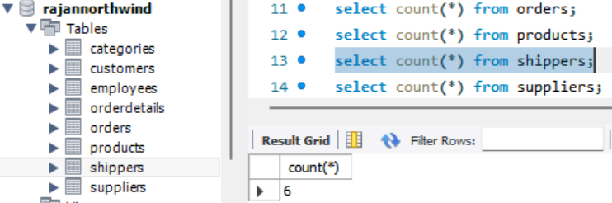

Suppliers

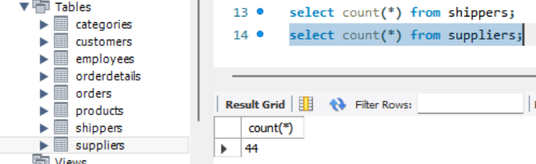

f. Check attributes and constraints in each table

Output:

Categories:

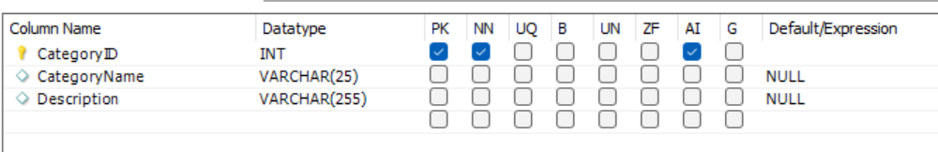

Customers:

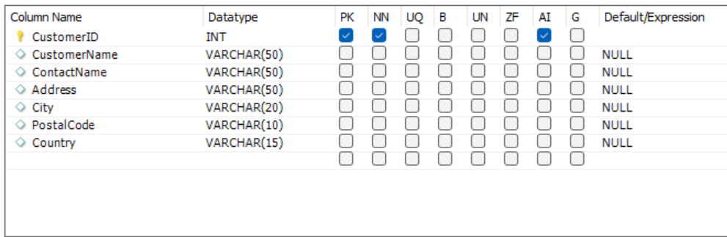

Employees:

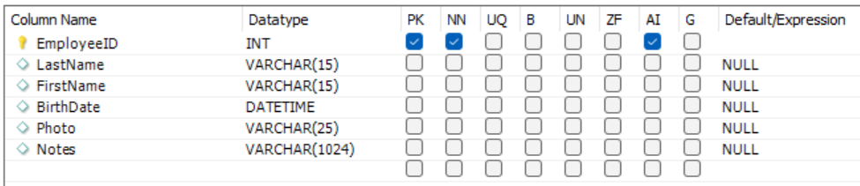

Order Details:

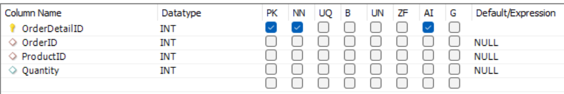

Orders:

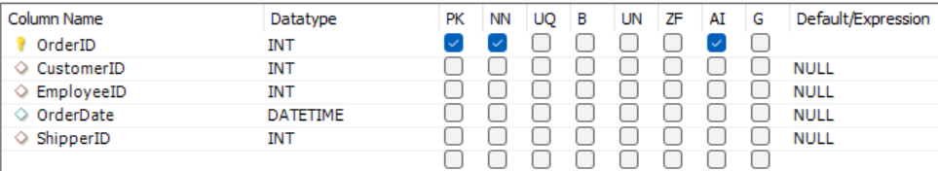

Products:

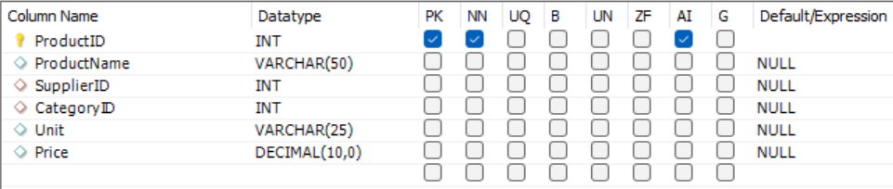

Shippers:

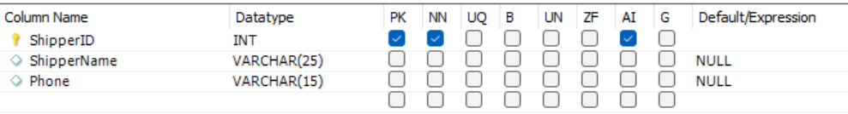

Suppliers:

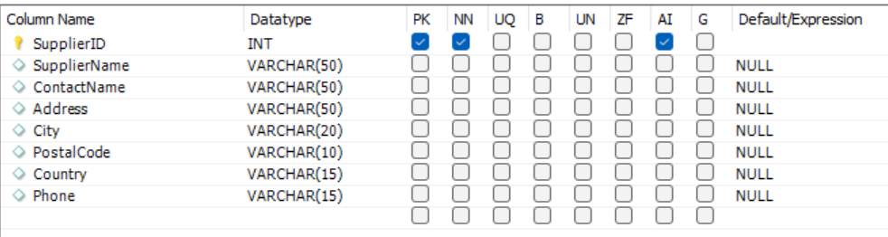

**B. Draw Entity Relationship Diagram**

a. Open any internet browser

b. Open <https://draw.io>

c. Select appropriate storage for your draw.io files (Prefer: Google Drive)

i. Authorize the access

d. Draw ER diagram of northwind database

i. Use appropriate shapes of ER diagram

ii. Use various colors to different Entity and attributes

**Output:**

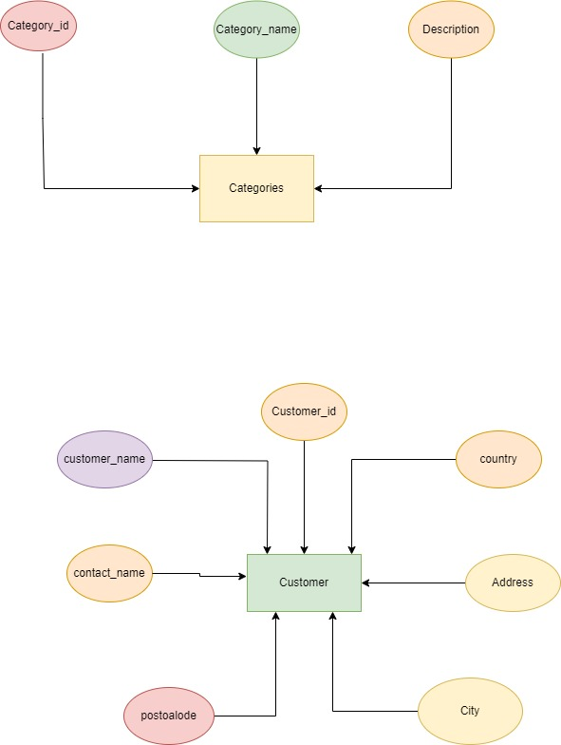

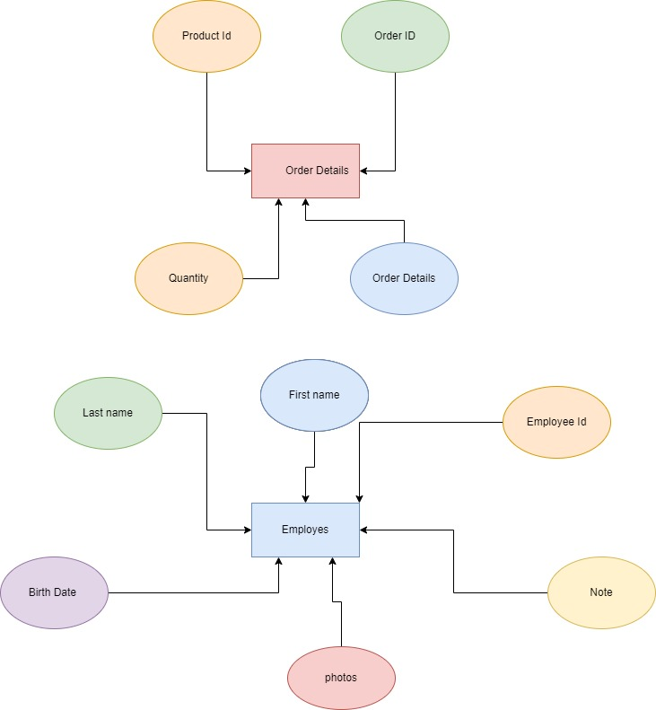

%3CmxGraphModel%3E%3Croot%3E%3CmxCell%20id%3D%220%22%2F%3E%3CmxCell%20id%3D%221%22%20parent%3D%220%22%2F%3E%3CmxCell%20id%3D%222%22%20value%3D%22Categories%22%20style%3D%22rounded%3D0%3BwhiteSpace%3Dwrap%3Bhtml%3D1%3BfillColor%3D%23fff2cc%3BstrokeColor%3D%23d6b656%3B%22%20vertex%3D%221%22%20parent%3D%221%22%3E%3CmxGeometry%20x%3D%22300%22%20y%3D%22210%22%20width%3D%22120%22%20height%3D%2270%22%20as%3D%22geometry%22%2F%3E%3C%2FmxCell%3E%3CmxCell%20id%3D%223%22%20style%3D%22edgeStyle%3DorthogonalEdgeStyle%3Brounded%3D0%3BorthogonalLoop%3D1%3BjettySize%3Dauto%3Bhtml%3D1%3BentryX%3D0%3BentryY%3D0.5%3BentryDx%3D0%3BentryDy%3D0%3B%22%20edge%3D%221%22%20target%3D%222%22%20parent%3D%221%22%3E%3CmxGeometry%20relative%3D%221%22%20as%3D%22geometry%22%3E%3CmxPoint%20x%3D%22290%22%20y%3D%22240%22%20as%3D%22targetPoint%22%2F%3E%3CmxPoint%20x%3D%22134.5%22%20y%3D%22102.5%22%20as%3D%22sourcePoint%22%2F%3E%3CArray%20as%3D%22points%22%3E%3CmxPoint%20x%3D%22135%22%20y%3D%22171%22%2F%3E%3CmxPoint%20x%3D%22136%22%20y%3D%22171%22%2F%3E%3CmxPoint%20x%3D%22136%22%20y%3D%22245%22%2F%3E%3C%2FArray%3E%3C%2FmxGeometry%3E%3C%2FmxCell%3E%3CmxCell%20id%3D%224%22%20value%3D%22Category_id%22%20style%3D%22ellipse%3BwhiteSpace%3Dwrap%3Bhtml%3D1%3BstrokeColor%3D%23b85450%3BfillColor%3D%23f8cecc%3B%22%20vertex%3D%221%22%20parent%3D%221%22%3E%3CmxGeometry%20x%3D%2290%22%20y%3D%2247.5%22%20width%3D%2280%22%20height%3D%2252.5%22%20as%3D%22geometry%22%2F%3E%3C%2FmxCell%3E%3CmxCell%20id%3D%225%22%20style%3D%22edgeStyle%3DorthogonalEdgeStyle%3Brounded%3D0%3BorthogonalLoop%3D1%3BjettySize%3Dauto%3Bhtml%3D1%3BentryX%3D1%3BentryY%3D0.5%3BentryDx%3D0%3BentryDy%3D0%3BexitX%3D0.5%3BexitY%3D1%3BexitDx%3D0%3BexitDy%3D0%3B%22%20edge%3D%221%22%20source%3D%226%22%20target%3D%222%22%20parent%3D%221%22%3E%3CmxGeometry%20relative%3D%221%22%20as%3D%22geometry%22%3E%3CmxPoint%20x%3D%22564.5%22%20y%3D%22250%22%20as%3D%22targetPoint%22%2F%3E%3CmxPoint%20x%3D%22564.5%22%20y%3D%22120%22%20as%3D%22sourcePoint%22%2F%3E%3C%2FmxGeometry%3E%3C%2FmxCell%3E%3CmxCell%20id%3D%226%22%20value%3D%22Description%22%20style%3D%22ellipse%3BwhiteSpace%3Dwrap%3Bhtml%3D1%3BfillColor%3D%23ffe6cc%3BstrokeColor%3D%23d79b00%3B%22%20vertex%3D%221%22%20parent%3D%221%22%3E%3CmxGeometry%20x%3D%22520%22%20y%3D%2247.5%22%20width%3D%2290%22%20height%3D%2260%22%20as%3D%22geometry%22%2F%3E%3C%2FmxCell%3E%3CmxCell%20id%3D%227%22%20style%3D%22edgeStyle%3DorthogonalEdgeStyle%3Brounded%3D0%3BorthogonalLoop%3D1%3BjettySize%3Dauto%3Bhtml%3D1%3BentryX%3D0.5%3BentryY%3D0%3BentryDx%3D0%3BentryDy%3D0%3B%22%20edge%3D%221%22%20source%3D%228%22%20target%3D%222%22%20parent%3D%221%22%3E%3CmxGeometry%20relative%3D%221%22%20as%3D%22geometry%22%2F%3E%3C%2FmxCell%3E%3CmxCell%20id%3D%228%22%20value%3D%22Category_name%22%20style%3D%22ellipse%3BwhiteSpace%3Dwrap%3Bhtml%3D1%3BfillColor%3D%23d5e8d4%3BstrokeColor%3D%2382b366%3B%22%20vertex%3D%221%22%20parent%3D%221%22%3E%3CmxGeometry%20x%3D%22315%22%20y%3D%2247.5%22%20width%3D%2290%22%20height%3D%2260%22%20as%3D%22geometry%22%2F%3E%3C%2FmxCell%3E%3CmxCell%20id%3D%229%22%20value%3D%22Customer%22%20style%3D%22rounded%3D0%3BwhiteSpace%3Dwrap%3Bhtml%3D1%3BfillColor%3D%23d5e8d4%3BstrokeColor%3D%2382b366%3B%22%20vertex%3D%221%22%20parent%3D%221%22%3E%3CmxGeometry%20x%3D%22350%22%20y%3D%22630%22%20width%3D%22120%22%20height%3D%2260%22%20as%3D%22geometry%22%2F%3E%3C%2FmxCell%3E%3CmxCell%20id%3D%2210%22%20style%3D%22edgeStyle%3DorthogonalEdgeStyle%3Brounded%3D0%3BorthogonalLoop%3D1%3BjettySize%3Dauto%3Bhtml%3D1%3BentryX%3D0.5%3BentryY%3D0%3BentryDx%3D0%3BentryDy%3D0%3B%22%20edge%3D%221%22%20source%3D%2211%22%20target%3D%229%22%20parent%3D%221%22%3E%3CmxGeometry%20relative%3D%221%22%20as%3D%22geometry%22%2F%3E%3C%2FmxCell%3E%3CmxCell%20id%3D%2211%22%20value%3D%22Customer_id%22%20style%3D%22ellipse%3BwhiteSpace%3Dwrap%3Bhtml%3D1%3BfillColor%3D%23ffe6cc%3BstrokeColor%3D%23d79b00%3B%22%20vertex%3D%221%22%20parent%3D%221%22%3E%3CmxGeometry%20x%3D%22365%22%20y%3D%22450%22%20width%3D%2290%22%20height%3D%2260%22%20as%3D%22geometry%22%2F%3E%3C%2FmxCell%3E%3CmxCell%20id%3D%2212%22%20style%3D%22edgeStyle%3DorthogonalEdgeStyle%3Brounded%3D0%3BorthogonalLoop%3D1%3BjettySize%3Dauto%3Bhtml%3D1%3B%22%20edge%3D%221%22%20parent%3D%221%22%3E%3CmxGeometry%20relative%3D%221%22%20as%3D%22geometry%22%3E%3CmxPoint%20x%3D%22371%22%20y%3D%22630%22%20as%3D%22targetPoint%22%2F%3E%3CmxPoint%20x%3D%22250%22%20y%3D%22531%22%20as%3D%22sourcePoint%22%2F%3E%3C%2FmxGeometry%3E%3C%2FmxCell%3E%3CmxCell%20id%3D%2213%22%20value%3D%22customer_name%22%20style%3D%22ellipse%3BwhiteSpace%3Dwrap%3Bhtml%3D1%3BfillColor%3D%23e1d5e7%3BstrokeColor%3D%239673a6%3B%22%20vertex%3D%221%22%20parent%3D%221%22%3E%3CmxGeometry%20x%3D%22150%22%20y%3D%22500%22%20width%3D%22100%22%20height%3D%2260%22%20as%3D%22geometry%22%2F%3E%3C%2FmxCell%3E%3CmxCell%20id%3D%2214%22%20style%3D%22edgeStyle%3DorthogonalEdgeStyle%3Brounded%3D0%3BorthogonalLoop%3D1%3BjettySize%3Dauto%3Bhtml%3D1%3BentryX%3D0.917%3BentryY%3D0%3BentryDx%3D0%3BentryDy%3D0%3BentryPerimeter%3D0%3B%22%20edge%3D%221%22%20source%3D%2215%22%20target%3D%229%22%20parent%3D%221%22%3E%3CmxGeometry%20relative%3D%221%22%20as%3D%22geometry%22%3E%3CmxPoint%20x%3D%22460%22%20y%3D%22520%22%20as%3D%22targetPoint%22%2F%3E%3C%2FmxGeometry%3E%3C%2FmxCell%3E%3CmxCell%20id%3D%2215%22%20value%3D%22country%22%20style%3D%22ellipse%3BwhiteSpace%3Dwrap%3Bhtml%3D1%3BfillColor%3D%23ffe6cc%3BstrokeColor%3D%23d79b00%3B%22%20vertex%3D%221%22%20parent%3D%221%22%3E%3CmxGeometry%20x%3D%22570%22%20y%3D%22500%22%20width%3D%2290%22%20height%3D%2260%22%20as%3D%22geometry%22%2F%3E%3C%2FmxCell%3E%3CmxCell%20id%3D%2216%22%20style%3D%22edgeStyle%3DorthogonalEdgeStyle%3Brounded%3D0%3BorthogonalLoop%3D1%3BjettySize%3Dauto%3Bhtml%3D1%3BentryX%3D1%3BentryY%3D0.5%3BentryDx%3D0%3BentryDy%3D0%3B%22%20edge%3D%221%22%20source%3D%2217%22%20target%3D%229%22%20parent%3D%221%22%3E%3CmxGeometry%20relative%3D%221%22%20as%3D%22geometry%22%2F%3E%3C%2FmxCell%3E%3CmxCell%20id%3D%2217%22%20value%3D%22Address%22%20style%3D%22ellipse%3BwhiteSpace%3Dwrap%3Bhtml%3D1%3BfillColor%3D%23fff2cc%3BstrokeColor%3D%23d6b656%3B%22%20vertex%3D%221%22%20parent%3D%221%22%3E%3CmxGeometry%20x%3D%22580%22%20y%3D%22630%22%20width%3D%22100%22%20height%3D%2260%22%20as%3D%22geometry%22%2F%3E%3C%2FmxCell%3E%3CmxCell%20id%3D%2218%22%20style%3D%22edgeStyle%3DorthogonalEdgeStyle%3Brounded%3D0%3BorthogonalLoop%3D1%3BjettySize%3Dauto%3Bhtml%3D1%3BentryX%3D0.25%3BentryY%3D1%3BentryDx%3D0%3BentryDy%3D0%3B%22%20edge%3D%221%22%20source%3D%2219%22%20target%3D%229%22%20parent%3D%221%22%3E%3CmxGeometry%20relative%3D%221%22%20as%3D%22geometry%22%3E%3CmxPoint%20x%3D%22400%22%20y%3D%22800%22%20as%3D%22targetPoint%22%2F%3E%3C%2FmxGeometry%3E%3C%2FmxCell%3E%3CmxCell%20id%3D%2219%22%20value%3D%22postoalode%22%20style%3D%22ellipse%3BwhiteSpace%3Dwrap%3Bhtml%3D1%3BfillColor%3D%23f8cecc%3BstrokeColor%3D%23b85450%3B%22%20vertex%3D%221%22%20parent%3D%221%22%3E%3CmxGeometry%20x%3D%22220%22%20y%3D%22770%22%20width%3D%2295%22%20height%3D%2260%22%20as%3D%22geometry%22%2F%3E%3C%2FmxCell%3E%3CmxCell%20id%3D%2220%22%20style%3D%22edgeStyle%3DorthogonalEdgeStyle%3Brounded%3D0%3BorthogonalLoop%3D1%3BjettySize%3Dauto%3Bhtml%3D1%3BentryX%3D0.75%3BentryY%3D1%3BentryDx%3D0%3BentryDy%3D0%3B%22%20edge%3D%221%22%20source%3D%2221%22%20target%3D%229%22%20parent%3D%221%22%3E%3CmxGeometry%20relative%3D%221%22%20as%3D%22geometry%22%3E%3CmxPoint%20x%3D%22440%22%20y%3D%22795%22%20as%3D%22targetPoint%22%2F%3E%3C%2FmxGeometry%3E%3C%2FmxCell%3E%3CmxCell%20id%3D%2221%22%20value%3D%22City%22%20style%3D%22ellipse%3BwhiteSpace%3Dwrap%3Bhtml%3D1%3BfillColor%3D%23fff2cc%3BstrokeColor%3D%23d6b656%3B%22%20vertex%3D%221%22%20parent%3D%221%22%3E%3CmxGeometry%20x%3D%22530%22%20y%3D%22760%22%20width%3D%22110%22%20height%3D%2270%22%20as%3D%22geometry%22%2F%3E%3C%2FmxCell%3E%3CmxCell%20id%3D%2222%22%20value%3D%22contact_name%22%20style%3D%22ellipse%3BwhiteSpace%3Dwrap%3Bhtml%3D1%3BfillColor%3D%23ffe6cc%3BstrokeColor%3D%23d79b00%3B%22%20vertex%3D%221%22%20parent%3D%221%22%3E%3CmxGeometry%20x%3D%22160%22%20y%3D%22620%22%20width%3D%2290%22%20height%3D%2260%22%20as%3D%22geometry%22%2F%3E%3C%2FmxCell%3E%3CmxCell%20id%3D%2223%22%20style%3D%22edgeStyle%3DorthogonalEdgeStyle%3Brounded%3D0%3BorthogonalLoop%3D1%3BjettySize%3Dauto%3Bhtml%3D1%3BentryX%3D-0.006%3BentryY%3D0.384%3BentryDx%3D0%3BentryDy%3D0%3BentryPerimeter%3D0%3B%22%20edge%3D%221%22%20source%3D%2222%22%20target%3D%229%22%20parent%3D%221%22%3E%3CmxGeometry%20relative%3D%221%22%20as%3D%22geometry%22%2F%3E%3C%2FmxCell%3E%3C%2Froot%3E%3C%2FmxGraphModel%3E

%3CmxGraphModel%3E%3Croot%3E%3CmxCell%20id%3D%220%22%2F%3E%3CmxCell%20id%3D%221%22%20parent%3D%220%22%2F%3E%3CmxCell%20id%3D%222%22%20value%3D%22Categories%22%20style%3D%22rounded%3D0%3BwhiteSpace%3Dwrap%3Bhtml%3D1%3BfillColor%3D%23fff2cc%3BstrokeColor%3D%23d6b656%3B%22%20vertex%3D%221%22%20parent%3D%221%22%3E%3CmxGeometry%20x%3D%22300%22%20y%3D%22210%22%20width%3D%22120%22%20height%3D%2270%22%20as%3D%22geometry%22%2F%3E%3C%2FmxCell%3E%3CmxCell%20id%3D%223%22%20style%3D%22edgeStyle%3DorthogonalEdgeStyle%3Brounded%3D0%3BorthogonalLoop%3D1%3BjettySize%3Dauto%3Bhtml%3D1%3BentryX%3D0%3BentryY%3D0.5%3BentryDx%3D0%3BentryDy%3D0%3B%22%20edge%3D%221%22%20target%3D%222%22%20parent%3D%221%22%3E%3CmxGeometry%20relative%3D%221%22%20as%3D%22geometry%22%3E%3CmxPoint%20x%3D%22290%22%20y%3D%22240%22%20as%3D%22targetPoint%22%2F%3E%3CmxPoint%20x%3D%22134.5%22%20y%3D%22102.5%22%20as%3D%22sourcePoint%22%2F%3E%3CArray%20as%3D%22points%22%3E%3CmxPoint%20x%3D%22135%22%20y%3D%22171%22%2F%3E%3CmxPoint%20x%3D%22136%22%20y%3D%22171%22%2F%3E%3CmxPoint%20x%3D%22136%22%20y%3D%22245%22%2F%3E%3C%2FArray%3E%3C%2FmxGeometry%3E%3C%2FmxCell%3E%3CmxCell%20id%3D%224%22%20value%3D%22Category_id%22%20style%3D%22ellipse%3BwhiteSpace%3Dwrap%3Bhtml%3D1%3BstrokeColor%3D%23b85450%3BfillColor%3D%23f8cecc%3B%22%20vertex%3D%221%22%20parent%3D%221%22%3E%3CmxGeometry%20x%3D%2290%22%20y%3D%2247.5%22%20width%3D%2280%22%20height%3D%2252.5%22%20as%3D%22geometry%22%2F%3E%3C%2FmxCell%3E%3CmxCell%20id%3D%225%22%20style%3D%22edgeStyle%3DorthogonalEdgeStyle%3Brounded%3D0%3BorthogonalLoop%3D1%3BjettySize%3Dauto%3Bhtml%3D1%3BentryX%3D1%3BentryY%3D0.5%3BentryDx%3D0%3BentryDy%3D0%3BexitX%3D0.5%3BexitY%3D1%3BexitDx%3D0%3BexitDy%3D0%3B%22%20edge%3D%221%22%20source%3D%226%22%20target%3D%222%22%20parent%3D%221%22%3E%3CmxGeometry%20relative%3D%221%22%20as%3D%22geometry%22%3E%3CmxPoint%20x%3D%22564.5%22%20y%3D%22250%22%20as%3D%22targetPoint%22%2F%3E%3CmxPoint%20x%3D%22564.5%22%20y%3D%22120%22%20as%3D%22sourcePoint%22%2F%3E%3C%2FmxGeometry%3E%3C%2FmxCell%3E%3CmxCell%20id%3D%226%22%20value%3D%22Description%22%20style%3D%22ellipse%3BwhiteSpace%3Dwrap%3Bhtml%3D1%3BfillColor%3D%23ffe6cc%3BstrokeColor%3D%23d79b00%3B%22%20vertex%3D%221%22%20parent%3D%221%22%3E%3CmxGeometry%20x%3D%22520%22%20y%3D%2247.5%22%20width%3D%2290%22%20height%3D%2260%22%20as%3D%22geometry%22%2F%3E%3C%2FmxCell%3E%3CmxCell%20id%3D%227%22%20style%3D%22edgeStyle%3DorthogonalEdgeStyle%3Brounded%3D0%3BorthogonalLoop%3D1%3BjettySize%3Dauto%3Bhtml%3D1%3BentryX%3D0.5%3BentryY%3D0%3BentryDx%3D0%3BentryDy%3D0%3B%22%20edge%3D%221%22%20source%3D%228%22%20target%3D%222%22%20parent%3D%221%22%3E%3CmxGeometry%20relative%3D%221%22%20as%3D%22geometry%22%2F%3E%3C%2FmxCell%3E%3CmxCell%20id%3D%228%22%20value%3D%22Category_name%22%20style%3D%22ellipse%3BwhiteSpace%3Dwrap%3Bhtml%3D1%3BfillColor%3D%23d5e8d4%3BstrokeColor%3D%2382b366%3B%22%20vertex%3D%221%22%20parent%3D%221%22%3E%3CmxGeometry%20x%3D%22315%22%20y%3D%2247.5%22%20width%3D%2290%22%20height%3D%2260%22%20as%3D%22geometry%22%2F%3E%3C%2FmxCell%3E%3CmxCell%20id%3D%229%22%20value%3D%22Customer%22%20style%3D%22rounded%3D0%3BwhiteSpace%3Dwrap%3Bhtml%3D1%3BfillColor%3D%23d5e8d4%3BstrokeColor%3D%2382b366%3B%22%20vertex%3D%221%22%20parent%3D%221%22%3E%3CmxGeometry%20x%3D%22350%22%20y%3D%22630%22%20width%3D%22120%22%20height%3D%2260%22%20as%3D%22geometry%22%2F%3E%3C%2FmxCell%3E%3CmxCell%20id%3D%2210%22%20style%3D%22edgeStyle%3DorthogonalEdgeStyle%3Brounded%3D0%3BorthogonalLoop%3D1%3BjettySize%3Dauto%3Bhtml%3D1%3BentryX%3D0.5%3BentryY%3D0%3BentryDx%3D0%3BentryDy%3D0%3B%22%20edge%3D%221%22%20source%3D%2211%22%20target%3D%229%22%20parent%3D%221%22%3E%3CmxGeometry%20relative%3D%221%22%20as%3D%22geometry%22%2F%3E%3C%2FmxCell%3E%3CmxCell%20id%3D%2211%22%20value%3D%22Customer_id%22%20style%3D%22ellipse%3BwhiteSpace%3Dwrap%3Bhtml%3D1%3BfillColor%3D%23ffe6cc%3BstrokeColor%3D%23d79b00%3B%22%20vertex%3D%221%22%20parent%3D%221%22%3E%3CmxGeometry%20x%3D%22365%22%20y%3D%22450%22%20width%3D%2290%22%20height%3D%2260%22%20as%3D%22geometry%22%2F%3E%3C%2FmxCell%3E%3CmxCell%20id%3D%2212%22%20style%3D%22edgeStyle%3DorthogonalEdgeStyle%3Brounded%3D0%3BorthogonalLoop%3D1%3BjettySize%3Dauto%3Bhtml%3D1%3B%22%20edge%3D%221%22%20parent%3D%221%22%3E%3CmxGeometry%20relative%3D%221%22%20as%3D%22geometry%22%3E%3CmxPoint%20x%3D%22371%22%20y%3D%22630%22%20as%3D%22targetPoint%22%2F%3E%3CmxPoint%20x%3D%22250%22%20y%3D%22531%22%20as%3D%22sourcePoint%22%2F%3E%3C%2FmxGeometry%3E%3C%2FmxCell%3E%3CmxCell%20id%3D%2213%22%20value%3D%22customer_name%22%20style%3D%22ellipse%3BwhiteSpace%3Dwrap%3Bhtml%3D1%3BfillColor%3D%23e1d5e7%3BstrokeColor%3D%239673a6%3B%22%20vertex%3D%221%22%20parent%3D%221%22%3E%3CmxGeometry%20x%3D%22150%22%20y%3D%22500%22%20width%3D%22100%22%20height%3D%2260%22%20as%3D%22geometry%22%2F%3E%3C%2FmxCell%3E%3CmxCell%20id%3D%2214%22%20style%3D%22edgeStyle%3DorthogonalEdgeStyle%3Brounded%3D0%3BorthogonalLoop%3D1%3BjettySize%3Dauto%3Bhtml%3D1%3BentryX%3D0.917%3BentryY%3D0%3BentryDx%3D0%3BentryDy%3D0%3BentryPerimeter%3D0%3B%22%20edge%3D%221%22%20source%3D%2215%22%20target%3D%229%22%20parent%3D%221%22%3E%3CmxGeometry%20relative%3D%221%22%20as%3D%22geometry%22%3E%3CmxPoint%20x%3D%22460%22%20y%3D%22520%22%20as%3D%22targetPoint%22%2F%3E%3C%2FmxGeometry%3E%3C%2FmxCell%3E%3CmxCell%20id%3D%2215%22%20value%3D%22country%22%20style%3D%22ellipse%3BwhiteSpace%3Dwrap%3Bhtml%3D1%3BfillColor%3D%23ffe6cc%3BstrokeColor%3D%23d79b00%3B%22%20vertex%3D%221%22%20parent%3D%221%22%3E%3CmxGeometry%20x%3D%22570%22%20y%3D%22500%22%20width%3D%2290%22%20height%3D%2260%22%20as%3D%22geometry%22%2F%3E%3C%2FmxCell%3E%3CmxCell%20id%3D%2216%22%20style%3D%22edgeStyle%3DorthogonalEdgeStyle%3Brounded%3D0%3BorthogonalLoop%3D1%3BjettySize%3Dauto%3Bhtml%3D1%3BentryX%3D1%3BentryY%3D0.5%3BentryDx%3D0%3BentryDy%3D0%3B%22%20edge%3D%221%22%20source%3D%2217%22%20target%3D%229%22%20parent%3D%221%22%3E%3CmxGeometry%20relative%3D%221%22%20as%3D%22geometry%22%2F%3E%3C%2FmxCell%3E%3CmxCell%20id%3D%2217%22%20value%3D%22Address%22%20style%3D%22ellipse%3BwhiteSpace%3Dwrap%3Bhtml%3D1%3BfillColor%3D%23fff2cc%3BstrokeColor%3D%23d6b656%3B%22%20vertex%3D%221%22%20parent%3D%221%22%3E%3CmxGeometry%20x%3D%22580%22%20y%3D%22630%22%20width%3D%22100%22%20height%3D%2260%22%20as%3D%22geometry%22%2F%3E%3C%2FmxCell%3E%3CmxCell%20id%3D%2218%22%20style%3D%22edgeStyle%3DorthogonalEdgeStyle%3Brounded%3D0%3BorthogonalLoop%3D1%3BjettySize%3Dauto%3Bhtml%3D1%3BentryX%3D0.25%3BentryY%3D1%3BentryDx%3D0%3BentryDy%3D0%3B%22%20edge%3D%221%22%20source%3D%2219%22%20target%3D%229%22%20parent%3D%221%22%3E%3CmxGeometry%20relative%3D%221%22%20as%3D%22geometry%22%3E%3CmxPoint%20x%3D%22400%22%20y%3D%22800%22%20as%3D%22targetPoint%22%2F%3E%3C%2FmxGeometry%3E%3C%2FmxCell%3E%3CmxCell%20id%3D%2219%22%20value%3D%22postoalode%22%20style%3D%22ellipse%3BwhiteSpace%3Dwrap%3Bhtml%3D1%3BfillColor%3D%23f8cecc%3BstrokeColor%3D%23b85450%3B%22%20vertex%3D%221%22%20parent%3D%221%22%3E%3CmxGeometry%20x%3D%22220%22%20y%3D%22770%22%20width%3D%2295%22%20height%3D%2260%22%20as%3D%22geometry%22%2F%3E%3C%2FmxCell%3E%3CmxCell%20id%3D%2220%22%20style%3D%22edgeStyle%3DorthogonalEdgeStyle%3Brounded%3D0%3BorthogonalLoop%3D1%3BjettySize%3Dauto%3Bhtml%3D1%3BentryX%3D0.75%3BentryY%3D1%3BentryDx%3D0%3BentryDy%3D0%3B%22%20edge%3D%221%22%20source%3D%2221%22%20target%3D%229%22%20parent%3D%221%22%3E%3CmxGeometry%20relative%3D%221%22%20as%3D%22geometry%22%3E%3CmxPoint%20x%3D%22440%22%20y%3D%22795%22%20as%3D%22targetPoint%22%2F%3E%3C%2FmxGeometry%3E%3C%2FmxCell%3E%3CmxCell%20id%3D%2221%22%20value%3D%22City%22%20style%3D%22ellipse%3BwhiteSpace%3Dwrap%3Bhtml%3D1%3BfillColor%3D%23fff2cc%3BstrokeColor%3D%23d6b656%3B%22%20vertex%3D%221%22%20parent%3D%221%22%3E%3CmxGeometry%20x%3D%22530%22%20y%3D%22760%22%20width%3D%22110%22%20height%3D%2270%22%20as%3D%22geometry%22%2F%3E%3C%2FmxCell%3E%3CmxCell%20id%3D%2222%22%20value%3D%22contact_name%22%20style%3D%22ellipse%3BwhiteSpace%3Dwrap%3Bhtml%3D1%3BfillColor%3D%23ffe6cc%3BstrokeColor%3D%23d79b00%3B%22%20vertex%3D%221%22%20parent%3D%221%22%3E%3CmxGeometry%20x%3D%22160%22%20y%3D%22620%22%20width%3D%2290%22%20height%3D%2260%22%20as%3D%22geometry%22%2F%3E%3C%2FmxCell%3E%3CmxCell%20id%3D%2223%22%20style%3D%22edgeStyle%3DorthogonalEdgeStyle%3Brounded%3D0%3BorthogonalLoop%3D1%3BjettySize%3Dauto%3Bhtml%3D1%3BentryX%3D-0.006%3BentryY%3D0.384%3BentryDx%3D0%3BentryDy%3D0%3BentryPerimeter%3D0%3B%22%20edge%3D%221%22%20source%3D%2222%22%20target%3D%229%22%20parent%3D%221%22%3E%3CmxGeometry%20relative%3D%221%22%20as%3D%22geometry%22%2F%3E%3C%2FmxCell%3E%3C%2Froot%3E%3C%2FmxGraphModel%3E

%3CmxGraphModel%3E%3Croot%3E%3CmxCell%20id%3D%220%22%2F%3E%3CmxCell%20id%3D%221%22%20parent%3D%220%22%2F%3E%3CmxCell%20id%3D%222%22%20value%3D%22Categories%22%20style%3D%22rounded%3D0%3BwhiteSpace%3Dwrap%3Bhtml%3D1%3BfillColor%3D%23fff2cc%3BstrokeColor%3D%23d6b656%3B%22%20vertex%3D%221%22%20parent%3D%221%22%3E%3CmxGeometry%20x%3D%22300%22%20y%3D%22210%22%20width%3D%22120%22%20height%3D%2270%22%20as%3D%22geometry%22%2F%3E%3C%2FmxCell%3E%3CmxCell%20id%3D%223%22%20style%3D%22edgeStyle%3DorthogonalEdgeStyle%3Brounded%3D0%3BorthogonalLoop%3D1%3BjettySize%3Dauto%3Bhtml%3D1%3BentryX%3D0%3BentryY%3D0.5%3BentryDx%3D0%3BentryDy%3D0%3B%22%20edge%3D%221%22%20target%3D%222%22%20parent%3D%221%22%3E%3CmxGeometry%20relative%3D%221%22%20as%3D%22geometry%22%3E%3CmxPoint%20x%3D%22290%22%20y%3D%22240%22%20as%3D%22targetPoint%22%2F%3E%3CmxPoint%20x%3D%22134.5%22%20y%3D%22102.5%22%20as%3D%22sourcePoint%22%2F%3E%3CArray%20as%3D%22points%22%3E%3CmxPoint%20x%3D%22135%22%20y%3D%22171%22%2F%3E%3CmxPoint%20x%3D%22136%22%20y%3D%22171%22%2F%3E%3CmxPoint%20x%3D%22136%22%20y%3D%22245%22%2F%3E%3C%2FArray%3E%3C%2FmxGeometry%3E%3C%2FmxCell%3E%3CmxCell%20id%3D%224%22%20value%3D%22Category_id%22%20style%3D%22ellipse%3BwhiteSpace%3Dwrap%3Bhtml%3D1%3BstrokeColor%3D%23b85450%3BfillColor%3D%23f8cecc%3B%22%20vertex%3D%221%22%20parent%3D%221%22%3E%3CmxGeometry%20x%3D%2290%22%20y%3D%2247.5%22%20width%3D%2280%22%20height%3D%2252.5%22%20as%3D%22geometry%22%2F%3E%3C%2FmxCell%3E%3CmxCell%20id%3D%225%22%20style%3D%22edgeStyle%3DorthogonalEdgeStyle%3Brounded%3D0%3BorthogonalLoop%3D1%3BjettySize%3Dauto%3Bhtml%3D1%3BentryX%3D1%3BentryY%3D0.5%3BentryDx%3D0%3BentryDy%3D0%3BexitX%3D0.5%3BexitY%3D1%3BexitDx%3D0%3BexitDy%3D0%3B%22%20edge%3D%221%22%20source%3D%226%22%20target%3D%222%22%20parent%3D%221%22%3E%3CmxGeometry%20relative%3D%221%22%20as%3D%22geometry%22%3E%3CmxPoint%20x%3D%22564.5%22%20y%3D%22250%22%20as%3D%22targetPoint%22%2F%3E%3CmxPoint%20x%3D%22564.5%22%20y%3D%22120%22%20as%3D%22sourcePoint%22%2F%3E%3C%2FmxGeometry%3E%3C%2FmxCell%3E%3CmxCell%20id%3D%226%22%20value%3D%22Description%22%20style%3D%22ellipse%3BwhiteSpace%3Dwrap%3Bhtml%3D1%3BfillColor%3D%23ffe6cc%3BstrokeColor%3D%23d79b00%3B%22%20vertex%3D%221%22%20parent%3D%221%22%3E%3CmxGeometry%20x%3D%22520%22%20y%3D%2247.5%22%20width%3D%2290%22%20height%3D%2260%22%20as%3D%22geometry%22%2F%3E%3C%2FmxCell%3E%3CmxCell%20id%3D%227%22%20style%3D%22edgeStyle%3DorthogonalEdgeStyle%3Brounded%3D0%3BorthogonalLoop%3D1%3BjettySize%3Dauto%3Bhtml%3D1%3BentryX%3D0.5%3BentryY%3D0%3BentryDx%3D0%3BentryDy%3D0%3B%22%20edge%3D%221%22%20source%3D%228%22%20target%3D%222%22%20parent%3D%221%22%3E%3CmxGeometry%20relative%3D%221%22%20as%3D%22geometry%22%2F%3E%3C%2FmxCell%3E%3CmxCell%20id%3D%228%22%20value%3D%22Category_name%22%20style%3D%22ellipse%3BwhiteSpace%3Dwrap%3Bhtml%3D1%3BfillColor%3D%23d5e8d4%3BstrokeColor%3D%2382b366%3B%22%20vertex%3D%221%22%20parent%3D%221%22%3E%3CmxGeometry%20x%3D%22315%22%20y%3D%2247.5%22%20width%3D%2290%22%20height%3D%2260%22%20as%3D%22geometry%22%2F%3E%3C%2FmxCell%3E%3CmxCell%20id%3D%229%22%20value%3D%22Customer%22%20style%3D%22rounded%3D0%3BwhiteSpace%3Dwrap%3Bhtml%3D1%3BfillColor%3D%23d5e8d4%3BstrokeColor%3D%2382b366%3B%22%20vertex%3D%221%22%20parent%3D%221%22%3E%3CmxGeometry%20x%3D%22350%22%20y%3D%22630%22%20width%3D%22120%22%20height%3D%2260%22%20as%3D%22geometry%22%2F%3E%3C%2FmxCell%3E%3CmxCell%20id%3D%2210%22%20style%3D%22edgeStyle%3DorthogonalEdgeStyle%3Brounded%3D0%3BorthogonalLoop%3D1%3BjettySize%3Dauto%3Bhtml%3D1%3BentryX%3D0.5%3BentryY%3D0%3BentryDx%3D0%3BentryDy%3D0%3B%22%20edge%3D%221%22%20source%3D%2211%22%20target%3D%229%22%20parent%3D%221%22%3E%3CmxGeometry%20relative%3D%221%22%20as%3D%22geometry%22%2F%3E%3C%2FmxCell%3E%3CmxCell%20id%3D%2211%22%20value%3D%22Customer_id%22%20style%3D%22ellipse%3BwhiteSpace%3Dwrap%3Bhtml%3D1%3BfillColor%3D%23ffe6cc%3BstrokeColor%3D%23d79b00%3B%22%20vertex%3D%221%22%20parent%3D%221%22%3E%3CmxGeometry%20x%3D%22365%22%20y%3D%22450%22%20width%3D%2290%22%20height%3D%2260%22%20as%3D%22geometry%22%2F%3E%3C%2FmxCell%3E%3CmxCell%20id%3D%2212%22%20style%3D%22edgeStyle%3DorthogonalEdgeStyle%3Brounded%3D0%3BorthogonalLoop%3D1%3BjettySize%3Dauto%3Bhtml%3D1%3B%22%20edge%3D%221%22%20parent%3D%221%22%3E%3CmxGeometry%20relative%3D%221%22%20as%3D%22geometry%22%3E%3CmxPoint%20x%3D%22371%22%20y%3D%22630%22%20as%3D%22targetPoint%22%2F%3E%3CmxPoint%20x%3D%22250%22%20y%3D%22531%22%20as%3D%22sourcePoint%22%2F%3E%3C%2FmxGeometry%3E%3C%2FmxCell%3E%3CmxCell%20id%3D%2213%22%20value%3D%22customer_name%22%20style%3D%22ellipse%3BwhiteSpace%3Dwrap%3Bhtml%3D1%3BfillColor%3D%23e1d5e7%3BstrokeColor%3D%239673a6%3B%22%20vertex%3D%221%22%20parent%3D%221%22%3E%3CmxGeometry%20x%3D%22150%22%20y%3D%22500%22%20width%3D%22100%22%20height%3D%2260%22%20as%3D%22geometry%22%2F%3E%3C%2FmxCell%3E%3CmxCell%20id%3D%2214%22%20style%3D%22edgeStyle%3DorthogonalEdgeStyle%3Brounded%3D0%3BorthogonalLoop%3D1%3BjettySize%3Dauto%3Bhtml%3D1%3BentryX%3D0.917%3BentryY%3D0%3BentryDx%3D0%3BentryDy%3D0%3BentryPerimeter%3D0%3B%22%20edge%3D%221%22%20source%3D%2215%22%20target%3D%229%22%20parent%3D%221%22%3E%3CmxGeometry%20relative%3D%221%22%20as%3D%22geometry%22%3E%3CmxPoint%20x%3D%22460%22%20y%3D%22520%22%20as%3D%22targetPoint%22%2F%3E%3C%2FmxGeometry%3E%3C%2FmxCell%3E%3CmxCell%20id%3D%2215%22%20value%3D%22country%22%20style%3D%22ellipse%3BwhiteSpace%3Dwrap%3Bhtml%3D1%3BfillColor%3D%23ffe6cc%3BstrokeColor%3D%23d79b00%3B%22%20vertex%3D%221%22%20parent%3D%221%22%3E%3CmxGeometry%20x%3D%22570%22%20y%3D%22500%22%20width%3D%2290%22%20height%3D%2260%22%20as%3D%22geometry%22%2F%3E%3C%2FmxCell%3E%3CmxCell%20id%3D%2216%22%20style%3D%22edgeStyle%3DorthogonalEdgeStyle%3Brounded%3D0%3BorthogonalLoop%3D1%3BjettySize%3Dauto%3Bhtml%3D1%3BentryX%3D1%3BentryY%3D0.5%3BentryDx%3D0%3BentryDy%3D0%3B%22%20edge%3D%221%22%20source%3D%2217%22%20target%3D%229%22%20parent%3D%221%22%3E%3CmxGeometry%20relative%3D%221%22%20as%3D%22geometry%22%2F%3E%3C%2FmxCell%3E%3CmxCell%20id%3D%2217%22%20value%3D%22Address%22%20style%3D%22ellipse%3BwhiteSpace%3Dwrap%3Bhtml%3D1%3BfillColor%3D%23fff2cc%3BstrokeColor%3D%23d6b656%3B%22%20vertex%3D%221%22%20parent%3D%221%22%3E%3CmxGeometry%20x%3D%22580%22%20y%3D%22630%22%20width%3D%22100%22%20height%3D%2260%22%20as%3D%22geometry%22%2F%3E%3C%2FmxCell%3E%3CmxCell%20id%3D%2218%22%20style%3D%22edgeStyle%3DorthogonalEdgeStyle%3Brounded%3D0%3BorthogonalLoop%3D1%3BjettySize%3Dauto%3Bhtml%3D1%3BentryX%3D0.25%3BentryY%3D1%3BentryDx%3D0%3BentryDy%3D0%3B%22%20edge%3D%221%22%20source%3D%2219%22%20target%3D%229%22%20parent%3D%221%22%3E%3CmxGeometry%20relative%3D%221%22%20as%3D%22geometry%22%3E%3CmxPoint%20x%3D%22400%22%20y%3D%22800%22%20as%3D%22targetPoint%22%2F%3E%3C%2FmxGeometry%3E%3C%2FmxCell%3E%3CmxCell%20id%3D%2219%22%20value%3D%22postoalode%22%20style%3D%22ellipse%3BwhiteSpace%3Dwrap%3Bhtml%3D1%3BfillColor%3D%23f8cecc%3BstrokeColor%3D%23b85450%3B%22%20vertex%3D%221%22%20parent%3D%221%22%3E%3CmxGeometry%20x%3D%22220%22%20y%3D%22770%22%20width%3D%2295%22%20height%3D%2260%22%20as%3D%22geometry%22%2F%3E%3C%2FmxCell%3E%3CmxCell%20id%3D%2220%22%20style%3D%22edgeStyle%3DorthogonalEdgeStyle%3Brounded%3D0%3BorthogonalLoop%3D1%3BjettySize%3Dauto%3Bhtml%3D1%3BentryX%3D0.75%3BentryY%3D1%3BentryDx%3D0%3BentryDy%3D0%3B%22%20edge%3D%221%22%20source%3D%2221%22%20target%3D%229%22%20parent%3D%221%22%3E%3CmxGeometry%20relative%3D%221%22%20as%3D%22geometry%22%3E%3CmxPoint%20x%3D%22440%22%20y%3D%22795%22%20as%3D%22targetPoint%22%2F%3E%3C%2FmxGeometry%3E%3C%2FmxCell%3E%3CmxCell%20id%3D%2221%22%20value%3D%22City%22%20style%3D%22ellipse%3BwhiteSpace%3Dwrap%3Bhtml%3D1%3BfillColor%3D%23fff2cc%3BstrokeColor%3D%23d6b656%3B%22%20vertex%3D%221%22%20parent%3D%221%22%3E%3CmxGeometry%20x%3D%22530%22%20y%3D%22760%22%20width%3D%22110%22%20height%3D%2270%22%20as%3D%22geometry%22%2F%3E%3C%2FmxCell%3E%3CmxCell%20id%3D%2222%22%20value%3D%22contact_name%22%20style%3D%22ellipse%3BwhiteSpace%3Dwrap%3Bhtml%3D1%3BfillColor%3D%23ffe6cc%3BstrokeColor%3D%23d79b00%3B%22%20vertex%3D%221%22%20parent%3D%221%22%3E%3CmxGeometry%20x%3D%22160%22%20y%3D%22620%22%20width%3D%2290%22%20height%3D%2260%22%20as%3D%22geometry%22%2F%3E%3C%2FmxCell%3E%3CmxCell%20id%3D%2223%22%20style%3D%22edgeStyle%3DorthogonalEdgeStyle%3Brounded%3D0%3BorthogonalLoop%3D1%3BjettySize%3Dauto%3Bhtml%3D1%3BentryX%3D-0.006%3BentryY%3D0.384%3BentryDx%3D0%3BentryDy%3D0%3BentryPerimeter%3D0%3B%22%20edge%3D%221%22%20source%3D%2222%22%20target%3D%229%22%20parent%3D%221%22%3E%3CmxGeometry%20relative%3D%221%22%20as%3D%22geometry%22%2F%3E%3C%2FmxCell%3E%3C%2Froot%3E%3C%2FmxGraphModel%3E

